*Development part 1*

# *Covid 19 vaccine analysis*

## Introduction:

Coronaviruses are a type of virus. There are many different kinds, and some cause disease. A coronavirus identified in 2019, SARS-CoV-2, has caused a pandemic of respiratory illness, called COVID-19.

In this project, we will analyze the Covid 19 dataset.

1. COVID-19 Vaccine Analysis
2. Default (GPT-3.5)
3. User
4. Covid 19 vaccine analysis
5. ChatGPT
6. Certainly, I can provide some general information on COVID-19 vaccines. If you have specific questions or topics you’d like to explore, feel free to ask
7. Types of Vaccines: There are different types of COVID-19 vaccines, including mRNA vaccines (e.g., Pfizer-BioNTech, Moderna), viral vector vaccines (e.g., Johnson & Johnson, AstraZeneca), and protein subunit vaccines (e.g., Novavax). Each type has its own mechanisms and advantages.
8. Efficacy: The efficacy of vaccines varies between different brands and can also vary with new variants of the virus. Efficacy is a measure of how well a vaccine prevents infection and illness.
9. Safety: COVID-19 vaccines have undergone extensive clinical trials to ensure safety. Common side effects are generally mild and temporary, such as sore arms and mild fever. Serious adverse events are rare.
10. Distribution and Access: Access to vaccines has been a global concern, with efforts to ensure equitable distribution, especially in low-income countries. Vaccine hesitancy and logistical challenges have been key issues.
11. Variants: Variants of the virus have the potential to affect vaccine effectiveness. Ongoing research and development are focused on adapting vaccines to address new variants.

Booster Shots: Booster shots have become a part of the vaccine strategy in many countries to maintain and extend immunity, especially in the face of new variants

# **Introduction**

Coronaviruses are a type of virus. There are many different kinds, and some cause disease. A coronavirus identified in 2019, SARS-CoV-2, has caused a pandemic of respiratory illness, called COVID-19.

In this project, we will analyze the Covid 19 dataset.

# **Data Importing**

In [1]:

import warnings

warnings.filterwarnings('ignore')

import numpy as np

import pandas as pd

import matplotlib.pyplot as plt

import plotly.express as px

import os

for dirname, _, filenames **in** os.walk('/kaggle/input'):

for filename **in** filenames:

print(os.path.join(dirname, filename))

/kaggle/input/corona-virus-report/covid_19_clean_complete.csv

/kaggle/input/corona-virus-report/country_wise_latest.csv

/kaggle/input/corona-virus-report/day_wise.csv

/kaggle/input/corona-virus-report/usa_county_wise.csv

/kaggle/input/corona-virus-report/worldometer_data.csv

/kaggle/input/corona-virus-report/full_grouped.csv

In [2]:

data = pd.read_csv("/kaggle/input/corona-virus-report/country_wise_latest.csv")

data

Out[2]:

|  | Country/Region | Confirmed | Deaths | Recovered | Active | New cases | New deaths | New recovered | Deaths / 100 Cases | Recovered / 100 Cases | Deaths / 100 Recovered | Confirmed last week | 1 week change | 1 week % increase | WHO Region |
| --- | --- | --- | --- | --- | --- | --- | --- | --- | --- | --- | --- | --- | --- | --- | --- |
| 0 | Afghanistan | 36263 | 1269 | 25198 | 9796 | 106 | 10 | 18 | 3.50 | 69.49 | 5.04 | 35526 | 737 | 2.07 | Eastern Mediterranean |
| 1 | Albania | 4880 | 144 | 2745 | 1991 | 117 | 6 | 63 | 2.95 | 56.25 | 5.25 | 4171 | 709 | 17.00 | Europe |
| 2 | Algeria | 27973 | 1163 | 18837 | 7973 | 616 | 8 | 749 | 4.16 | 67.34 | 6.17 | 23691 | 4282 | 18.07 | Africa |
| 3 | Andorra | 907 | 52 | 803 | 52 | 10 | 0 | 0 | 5.73 | 88.53 | 6.48 | 884 | 23 | 2.60 | Europe |
| 4 | Angola | 950 | 41 | 242 | 667 | 18 | 1 | 0 | 4.32 | 25.47 | 16.94 | 749 | 201 | 26.84 | Africa |
| ... | ... | ... | ... | ... | ... | ... | ... | ... | ... | ... | ... | ... | ... | ... | ... |
| 182 | West Bank and Gaza | 10621 | 78 | 3752 | 6791 | 152 | 2 | 0 | 0.73 | 35.33 | 2.08 | 8916 | 1705 | 19.12 | Eastern Mediterranean |
| 183 | Western Sahara | 10 | 1 | 8 | 1 | 0 | 0 | 0 | 10.00 | 80.00 | 12.50 | 10 | 0 | 0.00 | Africa |
| 184 | Yemen | 1691 | 483 | 833 | 375 | 10 | 4 | 36 | 28.56 | 49.26 | 57.98 | 1619 | 72 | 4.45 | Eastern Mediterranean |
| 185 | Zambia | 4552 | 140 | 2815 | 1597 | 71 | 1 | 465 | 3.08 | 61.84 | 4.97 | 3326 | 1226 | 36.86 | Africa |
| 186 | Zimbabwe | 2704 | 36 | 542 | 2126 | 192 | 2 | 24 | 1.33 | 20.04 | 6.64 | 1713 | 991 | 57.85 | Africa |

Country/Region 0

Confirmed 0

Deaths 0

Recovered 0

Active 0

New cases 0

New deaths 0

New recovered 0

Deaths / 100 Cases 0

Recovered / 100 Cases 0

Deaths / 100 Recovered 0

Confirmed last week 0

1 week change 0

1 week % increase 0

WHO Region 0

status_count = ['Confirmed', 'Deaths', 'Recovered', 'Active']

column_sums = data[status_count].sum().plot(kind='bar')

plt.xlabel("Status")

plt.ylabel("Count In Millions")

plt.title("Count of Population Status")

Out[7]:

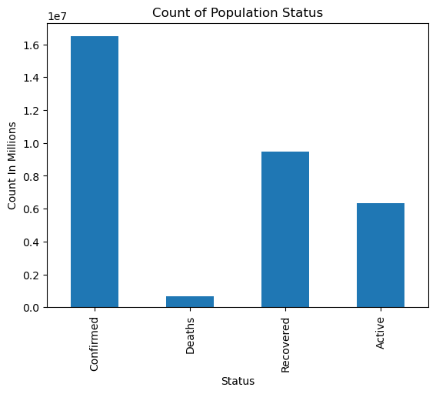Text(0.5, 1.0, 'Count of Population Status')

Region = data.groupby(by = 'WHO Region').sum()

Region.head()

Out[8]:

|  | Confirmed | Deaths | Recovered | Active | New cases | New deaths | New recovered | Deaths / 100 Cases | Recovered / 100 Cases | Deaths / 100 Recovered | Confirmed last week | 1 week change | 1 week % increase |
| --- | --- | --- | --- | --- | --- | --- | --- | --- | --- | --- | --- | --- | --- |
| WHO Region |  |  |  |  |  |  |  |  |  |  |  |  |  |
| Africa | 723207 | 12223 | 440645 | 270339 | 12176 | 353 | 14563 | 110.71 | 2736.71 | NaN | 608120 | 115087 | 868.15 |
| Americas | 8839286 | 342732 | 4468616 | 4027938 | 129531 | 3555 | 94776 | 106.84 | 2180.20 | NaN | 7815198 | 1024088 | 571.59 |
| Eastern Mediterranean | 1490744 | 38339 | 1201400 | 251005 | 12410 | 445 | 14843 | 78.39 | 1465.05 | NaN | 1398847 | 91897 | 230.61 |
| Europe | 3299523 | 211144 | 1993723 | 1094656 | 22294 | 304 | 11732 | 235.11 | 3843.56 | NaN | 3146816 | 152707 | 435.10 |
| South-East Asia | 1835297 | 41349 | 1156933 | 637015 | 48993 | 734 | 37582 | 12.96 | 667.04 | 19.56 | 1478283 | 357014 | 85.13 |

colors = ['skyblue', 'lightcoral', 'lightgreen', 'orange', 'purple', 'gold', 'pink']

Region['Confirmed'].plot(kind='pie', autopct='**%1.1f%%**', colors=colors)

plt.title('Distribution of Confirmed Cases by WHO Region')

plt.ylabel('')

plt.show()

